P12)

%P#12

s=tf('s');

sys=36/(s^2+2\*s+36)

step(sys)

grid

ylabel('C(t)');

ylim([0 2]);

xlim([0 6]);

legend('sys')

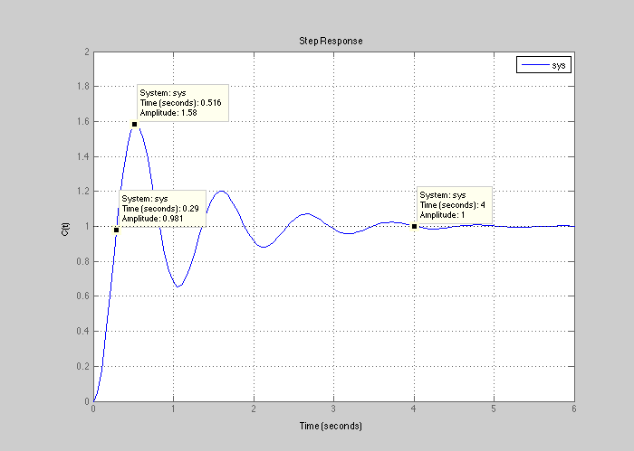

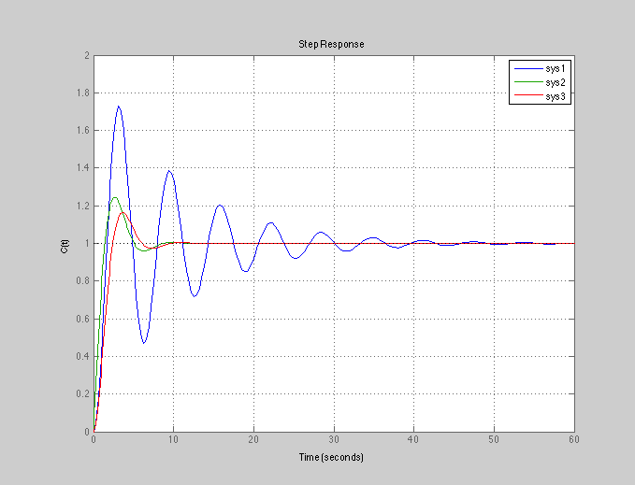P13)

%%

clc

clear

s=tf('s');

% P#13

sys1=5/(5\*s^2+s+5)

sys2=(1+.8\*s)/(s^2+s+1)

sys3=1/(s^2+s+1)

figure

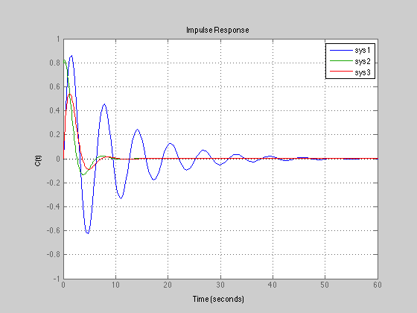hold on

step(sys1)

step(sys2)

step(sys3)

grid

ylabel('C(t)');

ylim([0 2]);

xlim([0 60]);

legend('sys1','sys2','sys3')

figure

hold on

impulse(sys1)

impulse(sys2)

impulse(sys3)

grid

ylabel('C(t)');

ylim([-1 1]);

xlim([0 60]);

legend('sys1','sys2','sys3')

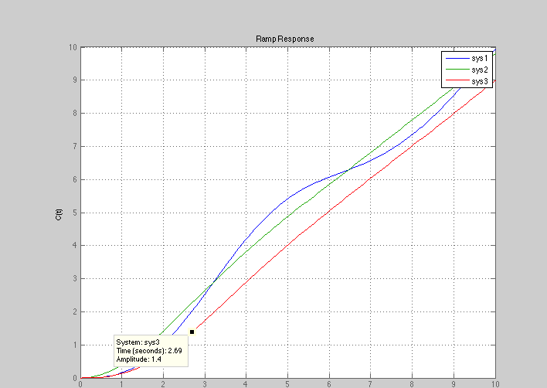

sys1=sys1\*(1/s)

sys2=sys2\*(1/s)

sys3=sys3\*(1/s)

figure

hold on

step(sys1)

step(sys2)

step(sys3)

grid

title('Ramp Response')

ylabel('C(t)');

ylim([0 10]);

xlim([0 10]);

legend('sys1','sys2','sys3')

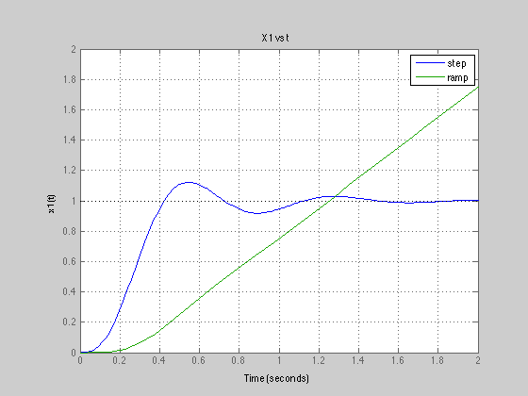P14)

%%

%P#14

clc

clear

s=tf('s');

R=(1/s);

x1=40/(.1\*s^3+s^2+10\*s+40)

x2=x1\*s

x3=x2\*(.01\*s+.1)

e=(x3\*s+x2)/4

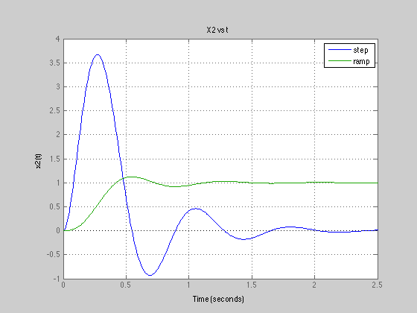figure(1)

hold on

step(x1)

step(x1\*R)

grid

title('X1 vs t')

ylabel('x1(t)');

ylim([0 2]);

xlim([0 2]);

legend('step','ramp')

figure(2)

hold on

step(x2)

step(x2\*R)

grid

title('X2 vs t')

ylabel('x2(t)');

ylim([-1 4]);

xlim([0 2.5]);

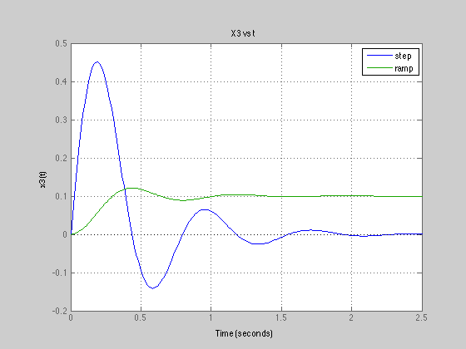legend('step','ramp')

figure(3)

hold on

step(x3)

step(x3\*R)

grid

title('X3 vs t')

ylabel('x3(t)');

ylim([-.2 .5]);

xlim([0 2.5]);

legend('step','ramp')

figure(4)

hold on

step(e)

step(e\*R)

grid

title('e vs t')

ylabel('e(t)');

ylim([-.2 1.2]);

xlim([0 2]);

legend('step','ramp')

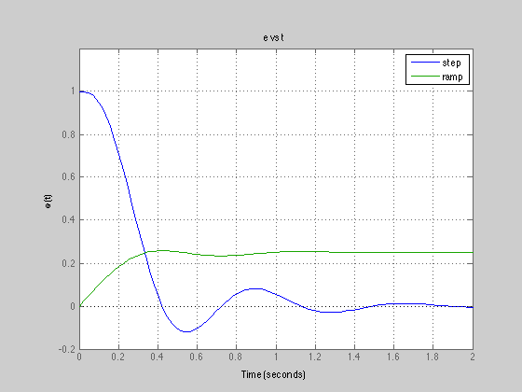

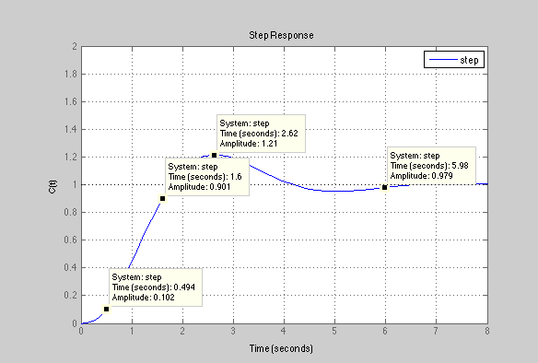

P15)

%%

%P#15

clc

clear

s=tf('s');

R=(1/s);

T=10/(s\*(s+2)\*(s+4)+10)

figure(1)

step(T)

grid

ylabel('C(t)');

ylim([0 2]);

xlim([0 8]);

legend('step')

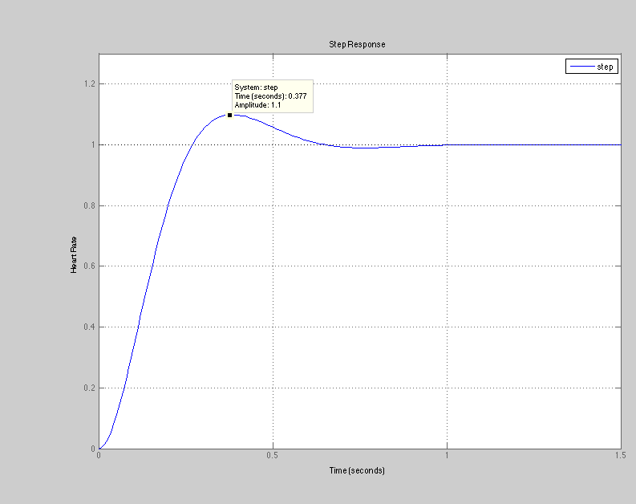

P1)

%%

%P#1

clc

clear

s=tf('s');

R=(1/s);

K=8.59;

T=K/(.083\*s^2+s+K)

figure(1)

step(T)

grid

ylabel('Heart Rate');

ylim([0 1.3]);

xlim([0 1.5]);

legend('step')

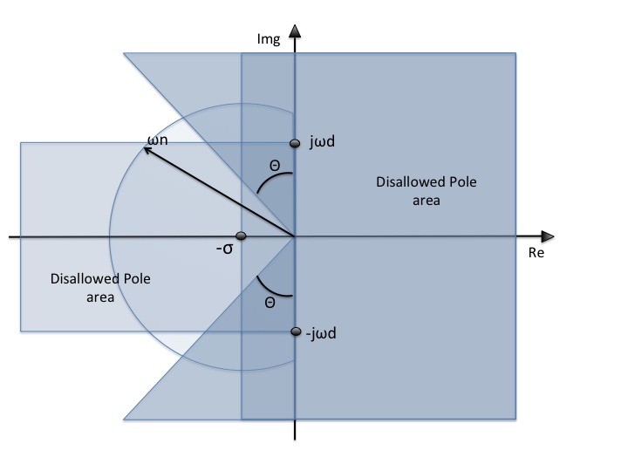P2)

P3)

